Tdap Toolkit
http://www.immunizekansascoalition.org/Tdap-toolkit-dh.asp
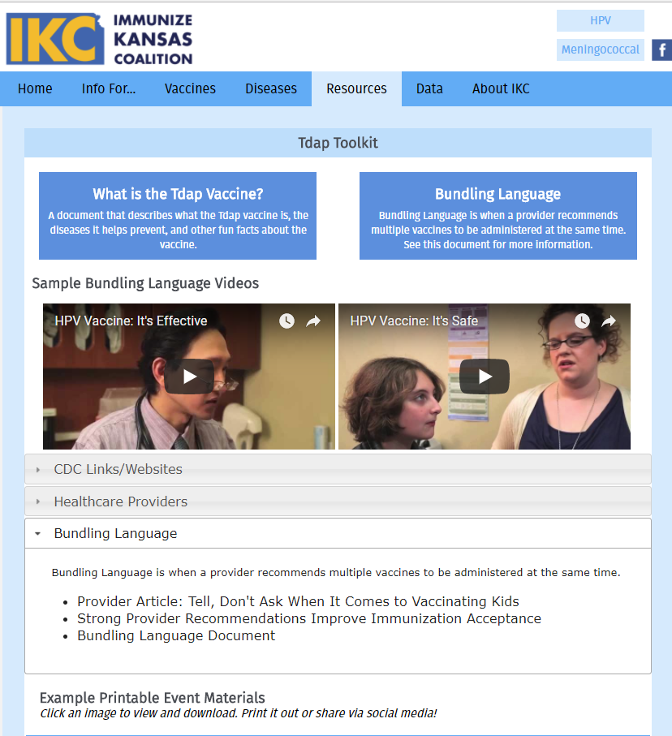
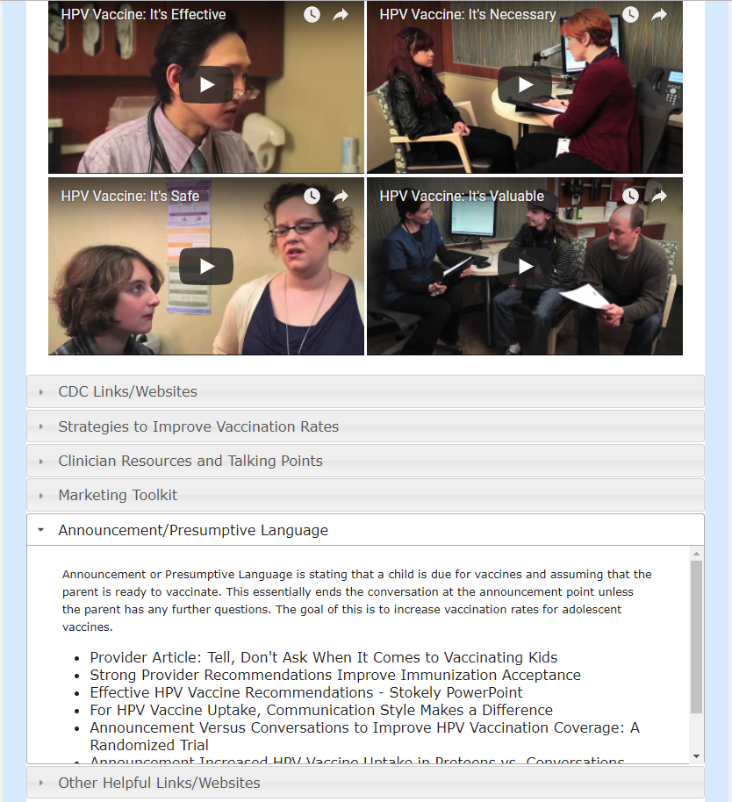
HPV Vaccine Toolkit
http://www.immunizekansascoalition.org/hpv-resources-dh.asp

